Spiderweb Game
Note to Facilitator:
This story is a real life case study of somebody who received support from one of our support workers. We have changed their name to protect their privacy. This exercise highlights the difficulties that Sam who finds himself homeless might face and the risks associated with it. Please give each participant a sticky label with the names from the case study (highlighted in bold) written on. The names are listed on the page below. You can give one person more than one character if required. Participants should note the label they have been given.
Explain that you will read out a case study about someone we have named Sam. The people with name badges are going to represent the agencies that our character will come into contact with in a period of less than 48 hours. When you as the facilitator are reading out the case study and your participants hear their role (marked in bold in this document), they should put their hand up so they can be given a piece of string to hold onto. Always take the string back to Sam to connect them to that contact. Sam should hold onto all the string as it comes back to him or it can be carefully wrapped around Sam’s body. You need a big ball of wool or string to make this exercise work successfully. There is a photo below to give you an idea of what the finished result should be.
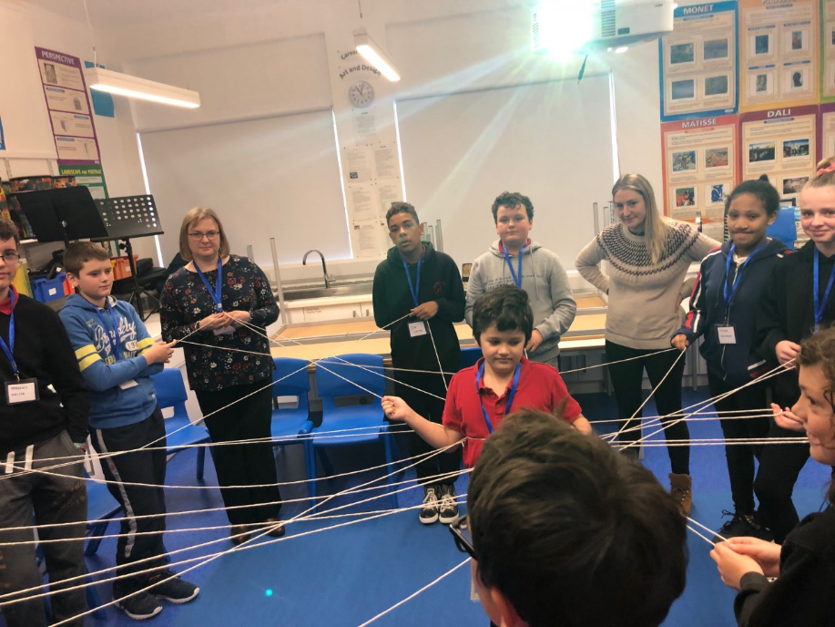
Stronsay Junior High, Orkney Islands

Labels needed:
- Sam
- Friend
- 3 Friends
- Housing Officer
- Emergency Shelter
- 2 Police Officers
- 2 Passers by
- A person who means well
- The Housing office
- Job Centre
- 2 Homeless Outreach Team Workers
- 3 Free Food places
- Clean Dry Clothes place
- Leaflets
- B&B
- Other residents
- Christine
- Social Bite

Case study

Sam is 22 years old and has recently become homeless. He’s been sleeping on his Friend’s sofa. There’s no family that he can turn to, as Sam’s parents were not nice parents to Sam, and he had to grow up in care. Tonight is a bad night. Sam had a fall out with the friend he’s been staying with, and now they’ve said Sam can’t stay there anymore. Now Sam has nowhere to go. It’s midnight. Sam begged to stay until the morning; but his friend said NO, you have to leave now.
Sam called 3 Friends but no one’s answering their phone. He takes a blanket and decides to walk around the town, maybe to sleep on a bench. He tries to call an ‘out of hours’ service for emergency accommodation. A Housing Officer informs Sam that there is no accommodation left that night, but there is an emergency shelter he can try. Sam goes to the Emergency Shelter but doesn’t find the place until 2am, only to find out that there are no places available there now either.
It’s now 2.30am and town is buzzing. It’s raining but loads of people are still out, most of which have had too much to drink. Sam walks around and eventually finds a small park, and a bench. Sam wipes off the rain and lies down under the blanket. Even though he’s cold and a bit damp he started to doze off… suddenly 2 Police Officers come past. The first officer wakes Sam up flashing a torchlight. The second says “You can’t sleep here, you have to move on”. Sam doesn’t know where to go. Sam wanders around and finds an alleyway. He’s so tired. Sam tries to settle in and rest, but it’s not a proper sleep. Two Drunk Passers By shout abuse at him which gives Sam a fright. 30 minutes later A Person Who Means Well leaves some takeaway food they’re too full to eat. It’s now 5am, so there’s just an hour or two till it gets light.
By 9am the next day, Sam is at The Housing Office. He doesn’t have a steady job so he struggles to have enough money, and he is told that he needs to sign up for “benefits” - which is where the Government makes sure you have some money to survive. To do this he is told he needs to phone the Job Centre. This takes hours, but he has to do it or he won’t have any money to get by. In the meantime Sam is introduced to a homeless outreach team. The Two Homeless Outreach Team Workers tell Sam about 3 Free Food Places to use at different times of the day such as church halls, and he is also told about a place he can get Clean Dry Clothes. Sam is given Leaflets about other places that help homeless and rough sleepers.
BUT ALL OF THIS INFORMATION IS A BIT CONFUSING. SAM STRUGGLES TO TRUST PEOPLE AND DOESN’T KNOW WHAT TO DO.
It’s already 3 ‘o’ clock in the afternoon. Sam is lucky enough to be given a space in a B&B. Sam hears something about it not being a typical B&B, apparently there’s are lots of rules. You can only be there at certain times and you have to leave in the morning, there are no visitors allowed, and no kitchen to make food in... never mind, all Sam can think about is: SHOWER AND SLEEP.
Sam waits for the B&B to open at 7 ‘o’ clock that night. It’s still winter and Sam’s cold outside until the B&B opens. When Sam arrives he notices immediately that the building is not what he expected. But he’s just grateful to have a room. He gets inside and discovers there’s a queue for the communal shower, so no private bathroom. Once Sam is showered and in dry clothes he goes to the room and sleeps on an uncomfortable bed. He wakes up to other residents arguing and yelling in the corridor outside his room in the middle of the night and struggles to get back to sleep.
Once the morning comes Sam leaves at 9am when everyone has to be out of the B&B again, not sure where to go or what to do next. Sam hears one of the others who spent the night there, Christine, talking about somewhere called Social Bite. Apparently it’s a high street cafe and if you’re struggling with homelessness you can pick up hot breakfast, lunch and a cup of coffee or water – all for free. Sam heads to Social Bite with Christine. When they arrive they’re told that they can also come back for dinner that day during a service called Social Suppers, where Social Bite’s Support Workers and other charities will all be there to help anybody who wants some face-to-face support.
THAT IS BASED ON A TRUE STORY. THIS STORY DOES NOT INCLUDE ADDICTIONS, PHYSICAL HEALTH ISSUES AND UNTREATED TRAUMA, YET STILL SHOWS HOW COMPLICATED THE EXPERIENCE WAS FOR SAM. CAN YOU IMAGINE HOW TOUGH IT WOULD BE IF YOU ALSO HAD AN ADDICTION, PHYSICAL OR MENTAL HEALTH ISSUES AS MANY PEOPLE EXPERIENCING HOMELESSNESS DO.

